**TABLE OF CONTENTS**

|  |  |  |  |
| --- | --- | --- | --- |
| **Figure No.** | **Figure Title** | **Page No.** | **Remarks** |
| 1 | Abstract |  |  |
| 2 | Introduction |  |  |
| 3 | Profile of the Problem |  |  |
| 4 | Feasibility Study |  |  |
| 5 | Software Requirement Specification |  |  |
| 6 | Design |  |  |
| 7 | Research Methodology |  |  |
| 8 | System Analysis |  |  |
| 9 | Details of Tools |  |  |
| 10 | Screenshots |  |  |
| 11 | Software Maintenance |  |  |
| 12 | Testing |  |  |
| 13 | Test Cases |  |  |
| 14 | Implementation |  |  |
| 15 | Discussion and Conclusion |  |  |
| 16 | Bibliography |  |  |

**ABSTRACT**

In the digital landscape of today, the "Blog Vista" website stands as a platform for sharing insights, narratives, and perspectives on a myriad of topics. With a focus on fostering meaningful discussions and providing a space for individuals to express themselves, Blog Vista aims to be a beacon of knowledge and inspiration.

The website's primary objective is to create a vibrant community where users can engage with diverse content ranging from personal anecdotes to thought-provoking analyses. Through a user-friendly interface and intuitive design, Blog Vista strives to deliver an enriching experience for both creators and readers alike.

In this abstract, we provide an overview of the "Blog Vista" website, detailing its profile, objectives, and scope. We delve into the technical feasibility of the project, outlining the system requirements and design considerations. Additionally, we discuss the methodology employed in the development process, along with the system analysis and testing phases.

With a commitment to excellence and a dedication to fostering creativity and collaboration, Blog Vista invites users to embark on a journey of exploration and discovery, where every click opens the door to new ideas and perspectives.

**INTRODUCTION**

In an era defined by digital connectivity and the sharing of ideas, "Blog Vista" emerges as a dynamic platform poised to cultivate a vibrant online community. At its core, "Blog Vista" is more than just a website; it's a space where individuals can explore, engage, and connect with others through the power of storytelling and dialogue.

The site has a user-friendly platform which allows users to freely write their thoughts and express themselves in front of the world.

The project includes a home page where the blogs posted by the community of blog vista are shown. There you can read different stories be it personal or educational. The user reading these blogs can also add his/her own blog to the site by joining the community. For this the user can sign up to the site and after signing up he/she can sign in to the platform. Then go to the add posts and add a new post for the community.

**PROFILE OF THE PROBLEM**

In today's fast-paced and interconnected world, the proliferation of digital content has led to an overwhelming abundance of information. While this presents opportunities for knowledge-sharing and engagement, it also brings forth challenges related to information overload, echo chambers, and a lack of authentic connection.

**Information Overload**: With the exponential growth of online content across various platforms, users often find themselves inundated with a deluge of information, making it difficult to discern valuable insights from noise.

**Echo Chambers and Polarization**: Social media algorithms and filter bubbles contribute to the formation of echo chambers, where individuals are exposed primarily to content that aligns with their existing beliefs, leading to polarization and the reinforcement of biases.

**Superficial Engagement**: The prevalence of short-form content and clickbait headlines on social media platforms can foster a culture of superficial engagement, where meaningful dialogue and critical thinking are often sidelined in favour of sensationalism and viral trends.

**Lack of Authentic Connection**: Despite the vast networks of connections facilitated by social media, many individuals experience a sense of disconnection and loneliness, as online interactions often lack the depth and authenticity found in face-to-face communication.

**Solution: "Blog Vista"**

"Blog Vista" seeks to address these challenges by providing a platform for authentic expression, meaningful dialogue, and community engagement. By fostering a culture of storytelling, empathy, and connection, "Blog Vista" aims to:

1. **Encourage Thoughtful Discourse**: Through long-form content and in-depth discussions, "Blog Vista" promotes critical thinking, empathy, and understanding, fostering a culture of respectful dialogue and constructive engagement.
2. **Facilitate Diverse Perspectives**: By embracing a wide range of content genres and viewpoints, "Blog Vista" celebrates diversity and inclusivity, encouraging users to explore new ideas, challenge assumptions, and broaden their horizons.
3. **Cultivate Authentic Connections**: "Blog Vista" provides a space for users to share their stories, experiences, and passions authentically, fostering genuine connections and relationships based on mutual respect and shared interests.
4. **Combat Information Overload**: With a curated selection of high-quality content and user-generated recommendations, "Blog Vista" helps users navigate the sea of information more effectively, enabling them to discover relevant and meaningful content tailored to their interests.

**EXISTING SYSTEM**

In the existing system, users rely on various social media platforms, online forums, and personal blogs to share their thoughts, stories, and opinions. However, these platforms often lack cohesion, depth, and authenticity, leading to challenges such as information overload, superficial engagement, and echo chambers.

**PROPOSED SYSTEM**

The proposed system, "Blog Vista," is a comprehensive blogging platform designed to address the shortcomings of existing platforms. By providing a centralized space for authentic expression, meaningful dialogue, and community engagement, Blog Vista aims to cultivate a vibrant online community where users can connect, learn, and grow.

**OBJECTIVES**

1. **Foster Meaningful Connections**: Create a platform where users can connect authentically, engage in thoughtful discourse, and build genuine relationships based on shared interests and values.
2. **Promote Diverse Perspectives**: Celebrate diversity and inclusivity by welcoming a wide range of content genres, viewpoints, and voices, fostering a culture of openness, empathy, and understanding.
3. **Empower Users**: Empower users to share their stories, experiences, and passions with confidence, knowing that their voices are valued and respected within the community.
4. **Combat Information Overload**: Curate high-quality content and provide personalized recommendations to help users navigate the vast sea of information more effectively, ensuring that they discover relevant and meaningful content tailored to their interests.
5. **Enhance User Experience**: Design an intuitive and user-friendly interface that prioritizes ease of navigation, readability, and accessibility, ensuring a seamless and enjoyable experience for users of all backgrounds and abilities.

**FUNCTIONALITIES**

1. User Registration and Authentication
2. Content Creation and Publishing
3. Commenting and Engagement Features
4. Content Discovery
5. User Profile Management
6. Social Sharing and Integration
7. Moderation and Content Management Tools
8. Analytics and Insights

**SCOPE**

1. Development of a web-based platform accessible across devices.
2. Design and implementation of core functionalities to support content creation, engagement, and community building.
3. Integration of features for user authentication, profile management, and social sharing.
4. Implementation of algorithms for content curation, recommendation, and moderation.
5. A section for personal blog or an archive corner for user to keep their stuff saved.
6. Having comments and count of likes and visibility on each posts entered by the user.
7. Deployment of robust security measures to protect user data and privacy.
8. Testing, refinement, and optimization of the platform to ensure a seamless and reliable user experience.

The scope of the "Blog Vista" project encompasses several key components, including:

1. **User Experience Design**: Emphasizing intuitive navigation, responsive layout, and visually appealing aesthetics to enhance user engagement and satisfaction.
2. **Content Management System**: Developing robust tools and features for content creation, editing, and moderation, ensuring a seamless and efficient publishing process for users.
3. **Community Engagement**: Implementing interactive features such as comments, likes, and shares to facilitate dialogue and interaction among users, fostering a sense of camaraderie and connection.
4. **Data Security and Privacy**: Prioritizing the protection of user data and privacy through secure authentication mechanisms, data encryption, and adherence to best practices in data handling and storage.

**FEATURES**

1. User-friendly Interface: Intuitive navigation, responsive design, and visually appealing aesthetics.
2. Content Creation Tools: Rich text editor, multimedia support, and draft saving capabilities.
3. Engagement Features: Comments, likes, shares, and follow functionalities.
4. Content Discovery: Search functionality, categories, tags, and personalized recommendations.
5. User Profiles: Customizable profiles, bio sections, and activity feeds.
6. Moderation Tools: Reporting, flagging, and content review systems.
7. Analytics Dashboard: Insights into user engagement, content performance, and audience demographics.
8. Social Integration: Seamless integration with social media platforms for easy sharing and cross-promotion.

**MODULES**

1. User Management Module
2. Content Management Module
3. Engagement Module
4. Moderation Module
5. Analytics Module
6. Social Integration Module

**FEASIBILITY STUDY**

**1. Technical Feasibility:**

* **Hardware Requirements:** The technical infrastructure required for hosting the "Blog Vista" website includes web servers, storage systems, and networking equipment. These can be sourced from cloud service providers like Amazon Web Services (AWS) or Microsoft Azure to ensure scalability, reliability, and cost-effectiveness.
* **Software Requirements:** Development tools and software frameworks such as PHP, MySQL, HTML, CSS, and JavaScript will be used for building the website. These technologies are widely supported, well-documented, and offer robust features for web development.
* **Development Team:** A skilled team of developers proficient in web development technologies will be required to design, develop, and maintain the "Blog Vista" platform. This may involve hiring or outsourcing talent with expertise in front-end and back-end development, UI/UX design, and database management.

**2. Economic Feasibility:**

* **Cost Analysis:** The economic feasibility of the project will depend on factors such as development costs, operational expenses, and potential revenue streams. Initial investments will be required for hardware, software licenses, development resources, and marketing efforts.
* **Revenue Model:** Revenue generation strategies such as advertising, sponsored content, premium memberships, and affiliate marketing can be explored to monetize the "Blog Vista" platform and offset operational costs.
* **Return on Investment (ROI):** A thorough cost-benefit analysis will be conducted to evaluate the ROI of the project and determine its long-term sustainability and profitability.

**3. Operational Feasibility:**

* **User Acceptance:** The success of the "Blog Vista" project depends on user adoption and engagement. Extensive user research and testing will be conducted to understand user needs, preferences, and pain points, ensuring that the platform meets the expectations of its target audience.
* **Scalability and Performance:** Operational feasibility will be assessed in terms of the platform's ability to handle increasing user traffic, content volume, and feature enhancements over time. Scalability measures such as load balancing, caching, and database optimization will be implemented to ensure smooth operation under varying workloads.
* **Maintenance and Support:** Adequate resources and processes will be put in place for ongoing maintenance, updates, and technical support to address user feedback, fix bugs, and implement new features as needed.

**Problem Definition** The problem that "Blog Vista" addresses is the lack of a centralized platform for authentic expression, meaningful dialogue, and community engagement in the digital landscape. Existing social media platforms and online forums often prioritize quantity over quality, leading to information overload, echo chambers, and superficial engagement. "Blog Vista" aims to provide a solution by offering a curated space where users can connect, learn, and grow through the power of storytelling and dialogue.

**Feasibility Analysis** The feasibility analysis of the "Blog Vista" project concludes that the technical, economic, and operational aspects of the project are favourable for implementation. The technical infrastructure, software tools, and development expertise required for building the platform are readily available and accessible. From an economic perspective, the project presents viable revenue opportunities through various monetization strategies. Operationally, the platform is designed to meet user needs, scale with user growth, and provide ongoing maintenance and support. Overall, the feasibility analysis indicates that "Blog Vista" has the potential to address the identified problem effectively and achieve its objectives in the digital landscape.

**Minimum Requirements:-**

HARDWARE REQUIREMENTS:-

* Processor: Pentium IV with 2 GHz or Higher
* RAM: 512 MB
* Operating Environment: Enterprise 64-bit

SOFTWARE REQUIREMENTS:-

* Platform: Windows XP, MAC
* Browser: Google Chrome, Mozilla Firefox, Internet Explorer 7
* Platform XAMPP Version: 8.0.7
* Database MYSQLI
* Language: HTML, CSS, PHP, MySQL
* For Users: Internet Connection

**SOFTWARE REQUIREMENT SPECIFICATION**

**Software Requirement Specification:-**

The Software Requirements Specification is produced at the culmination of the analysis task. The function and performance allocated to software as part of system engineering are refined by establishing a complete information description, a detailed functional and behavioural description, an indication of performance requirements and design constraints, appropriate validation criteria, and other data pertinent to requirements.

**The proposed system has the following requirements:-**

* System needs to store information about the new entry of the blog.
* System needs to have the information of the individual blogs for the personal that is my posts section.
* System needs to edit and delete the blogs.
* It also needs a security system to prevent data.

**System Requirements:**

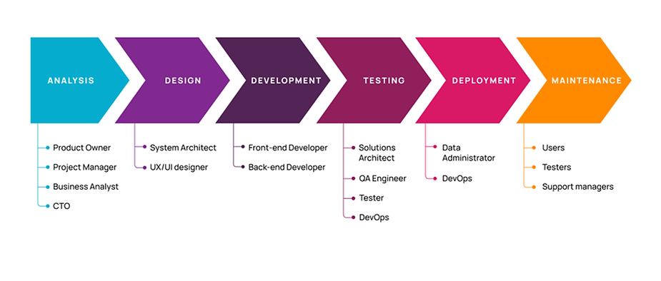

**DESIGN**

The Design Phase is an essential phase of the software development life cycle. The list of requirements that you develop in the definition phase is used to make design choices. These design phase products include dioramas, flow chart, sketches, site trees, HTML screen designs, photo impressions, prototypes, and UML schemas.

For assessing user requirements, an SRS document is created whereas for coding and implementation, there is a need of specific and detailed requirements in software terms. The output of this process can directly be used into implementation in programming into implementation in programming languages. Software design is the first step in SDLC which moves the concentration from problem domain to solution domain. It tries to specify how to fulfil the requirements mentioned in SRS.

**Software design levels**

* **Architecture design:-** The architectural design is the highest abstract version of the system it identifies the software as a system with many components interacting with each other. At this level the designer get the idea of proposed solution domain.
* **High level design:-** The high level design break the single entity multiple component concept of architectural design into less abstracted view of subsystems and modulus and depict their interaction with each other, High level design focus on how the system along with all of its component can be implemented in form of modulus. It recognizes modular structure of each subsystem and their relation and interaction among each other.
* **Detail design:-** Detailed design deals with implementation part of what is seen as a system and its sub system in the previous two designs. It is more detailed towards modules and their implementation. It defines logical structure of each module and their interfaces to communicate with other modules.

**Objectives:-**

Successful completion of the SDLC Design Phase comprise:

* Transformation of all the requirements into detailed specifications covering all the aspect of the system.
* Planning and assessment for security risks.
* Approval for progressing to development phase.

**RESEARCH METHODOLOGY**

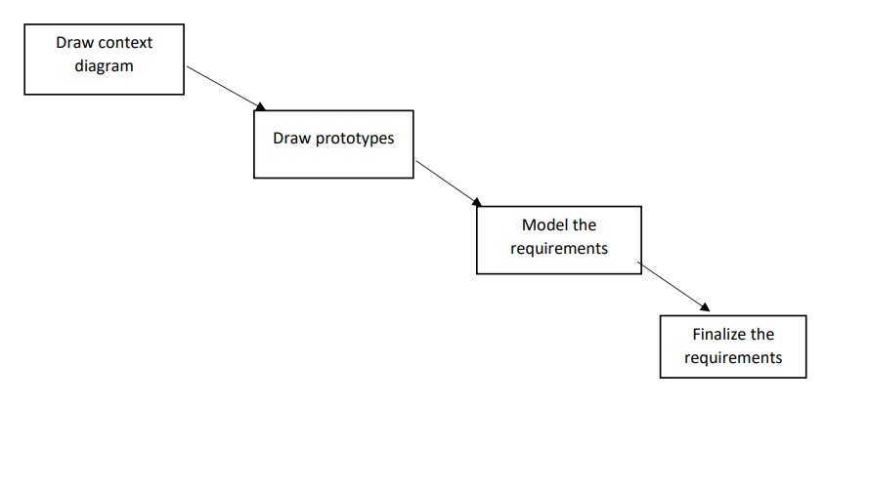

* **Draw Context Diagrams** – The context diagram is a simple model that defines the boundaries and interfaces of the proposed system with the external world. It identifies the entities outside the proposed system that interact with the system.
* **Development Of Prototype** – One effective way to find out what the customer really wants is to construct a prototype, something that looks and preferably acts like a part of the system they want.
* **Model The Requirement** – This process really consist of various graphical representations of functions, data entities, external entities and the relationship between them. The graphical view may help to find incorrect, inconsistent, missing and superfluous requirement.
* **Finalize The Requirements** – After modelling the requirements we will have better understanding of the system behaviour. The inconsistencies and ambiguities have been identified and corrected.

**SYSTEM ANALYSIS**

The objective of the system analysis activity is to develop structured system specification for the proposed system. The structured system specification should describe what the proposed system would do; independent of the technology, which will be used to implement these requirements. The structured system specification will be used to implement these requirements. The structured system specification will be called the essential model (also known as logical model). The essential model may itself consist of multiple models, modelling different aspect of the system. The data flow diagrams may model the data and their relationships and the state transition diagram may model time dependent behaviour of the system. The essential model thus consists of the following.

* Context diagram
* Levelled data flow diagrams
* Process specification for elementary bubbles.
* Data dictionary for the flow and stores on the DFDs.

**Context Level Diagram:**

The Context Diagram shows the system under consideration as a single high-level process and then shows the relationship that the system has with other external entities (systems, organizational groups, external data stores, etc).

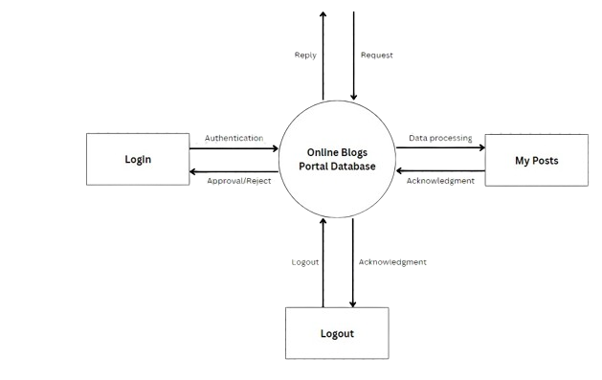

**ER DIAGRAM:**

Entity relationship diagrams are a way to represent the structure and layout of a database. It is used frequently to describe the database schema. ER diagrams are very useful as they provide a good conceptual view of any database, regardless of the underlying hardware and software. An ERD is a model that identifies the concepts or entities that exist in a system and the relationships between those entities. An ERD is often used as a way to visualize a relational database: each entity represents a database table, and the relationship lines represent the keys in one table that point to specific records in related tables.

ERDs may also be more abstract, not necessarily capturing every table needed within a database, but serving to diagram the major concepts and relationships. This ERD is of the latter type, intended to present an abstract, theoretical view of the major entities and relationships needed for management of electronic resources. It may assist the database design process for an e-resource management system but does not identify every table that would be necessary for an electronic resource management database.

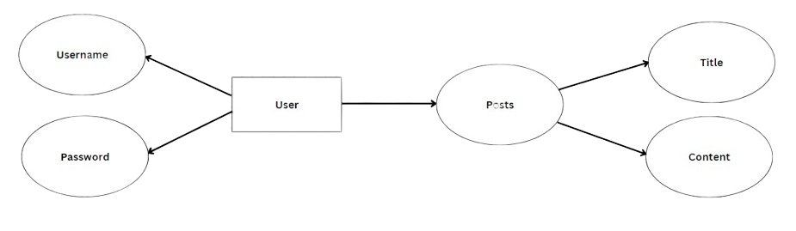

**DETAILS OF TOOLS**

In the detail of tools, we defined the tools we used that in this website the tools which are used by user.

Tools and Techniques are following:

* PHP
* XAMPP
* MYSQL
* HTML
* Visual Studio
* CSS

**PHP:**

PHP Hypertext Preprocessor (or simply PHP) is a server-side scripting language designed for Web development, but also used as a general-purpose programming language. It was originally created by Rasmus Lerdorf in 1994, the PHP reference implementation is now produced by The PHP Group. PHP 5 originally stood for Personal Home Page, but it now stands for the recursive acronym PHP: Hypertext Preprocessor. PHP code may be embedded into HTML code, or it can be used in combination with various web template systems, web content management systems, and web frameworks. PHP code is usually processed by a PHP interpreter implemented as a module in the web server or Gateway Interface (CGI) executable. The web server combines the results of the interpreted and executed PHP code, which may be any type of data, including images, with the generated web page. PHP code may also be executed with a command-line interface (CLI) and can be used to implement standalone graphical applications.

**XAMPP:**

XAMPP is a free and open source cross-platform web server solution stack package developed by Apache Friends, consisting mainly of the Apache HTTP Server, MariaDB database, and interpreters for scripts written in the PHP and Perl programming languages. XAMPP stands for Cross-Platform (X), Apache (A), MariaDB (M), PHP (P) and Perl (P). It is a simple, lightweight Apache distribution that makes it extremely easy for developers to create a local web server for testing and deployment purposes. Everything needed to set up a web server – server application (Apache), database (MariaDB), and scripting language (PHP) – is included in an extractable file. XAMPP is also cross-platform, which means it works equally well on Linux, Mac and Windows. Since most actual web server deployments use the same components as XAMPP, it makes transitioning from a local test server to a live server extremely easy as well.

**MYSQL:**

MySQL Workbench is a unified visual tool for database architects, developers, and DBAs. MySQL Workbench provides data modeling, SQL development, and comprehensive administration tools for server configuration, user administration, backup, and much more. MySQL Workbench is available on Windows, Linux and Mac OS X.

**HTML:**

HTML Hypertext Markup Language (HTML) is the standard markup language for creating web pages and web applications. With Cascading Style Sheets (CSS) and JavaScript, it forms a triad of cornerstone technologies for the World Wide Web. Web browsers receive HTML documents from a web server or from local storage and render the documents into multimedia web pages. HTML describes the structure of a web page semantically and originally included cues for the appearance of the document. HTML elements are the building blocks of HTML pages. With HTML constructs, images and other objects such as interactive forms may be embedded into the rendered page. HTML provides a means to 6 create structured documents by denoting structural semantics for text such as headings, paragraphs, lists, links, quotes and other items.

**CSS:**

Cascading Style Sheets (CSS) is a style sheet language used for describing the presentation of a document written in a markup language like HTML. CSS is a cornerstone technology of the World Wide Web, alongside HTML and JavaScript. CSS is designed to enable the separation of presentation and content, including layout, colors, and fonts. This separation can improve content accessibility, provide more flexibility and control in the specification of presentation characteristics, enable multiple web pages to share formatting by specifying the relevant CSS in a separate CSS file, and reduce complexity and repetition in the structural content.

**SCREENSHOTS**

**Home Page**

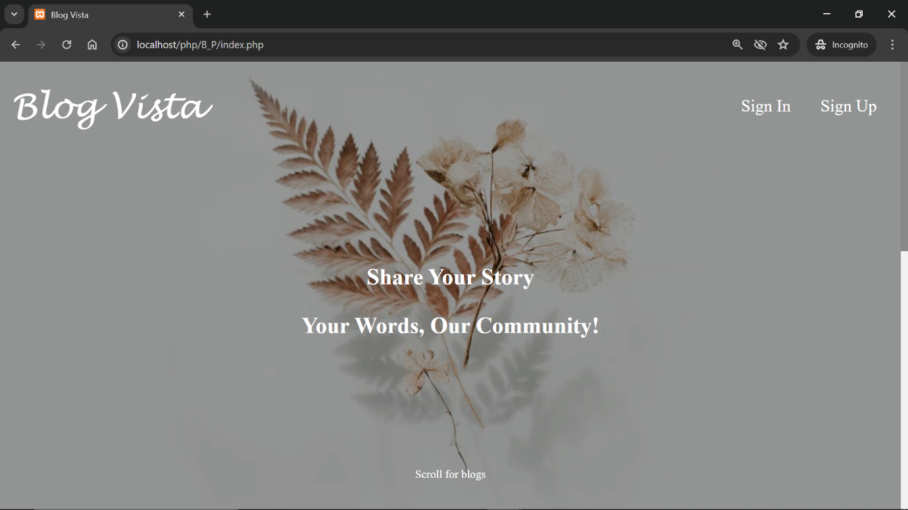

**After Sign In**

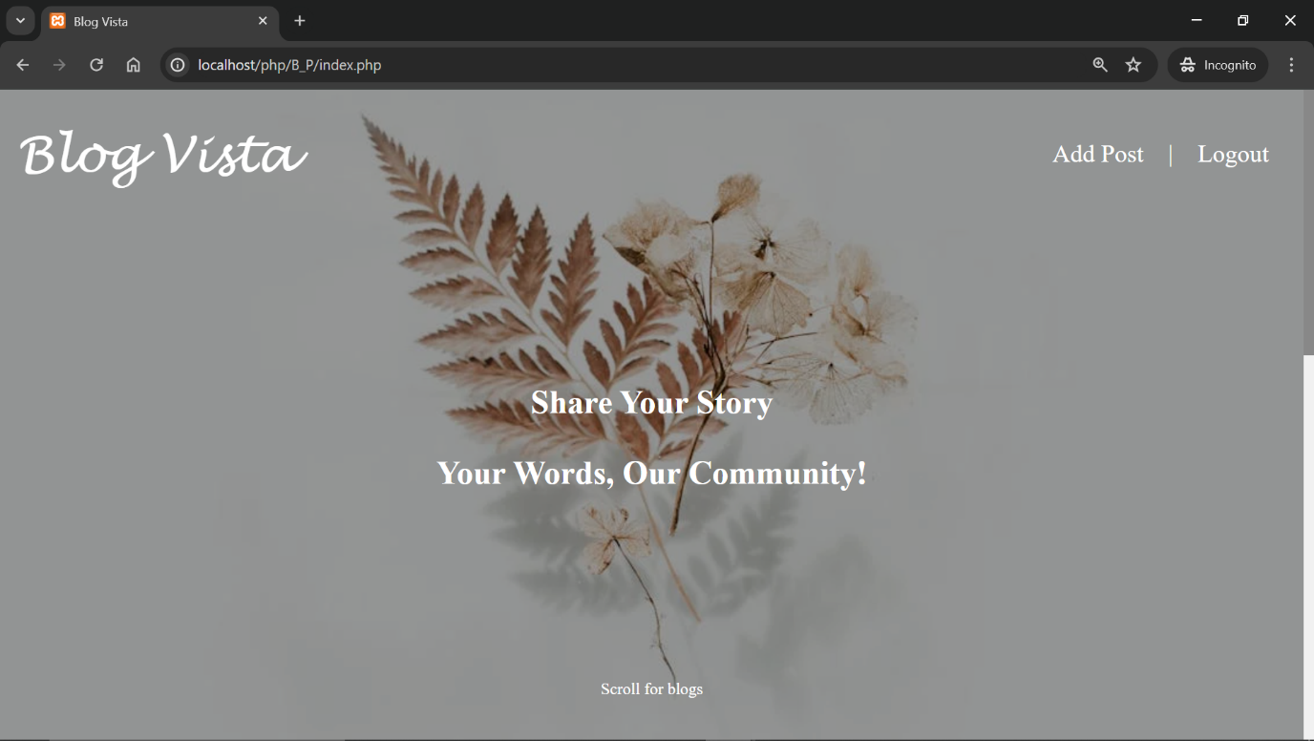



**Added Posts**

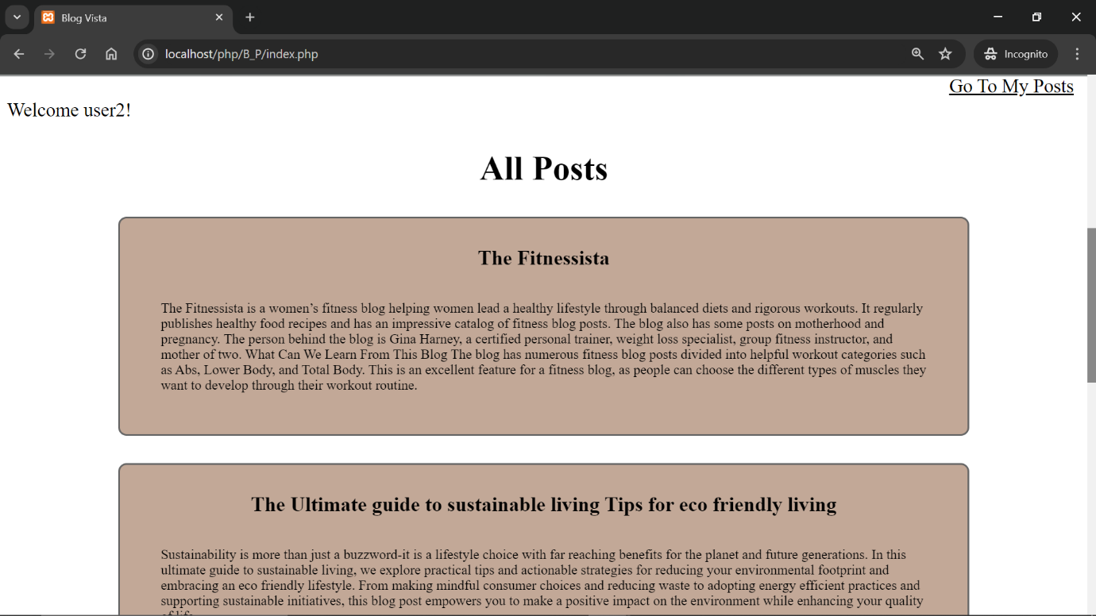

**Sign Up**

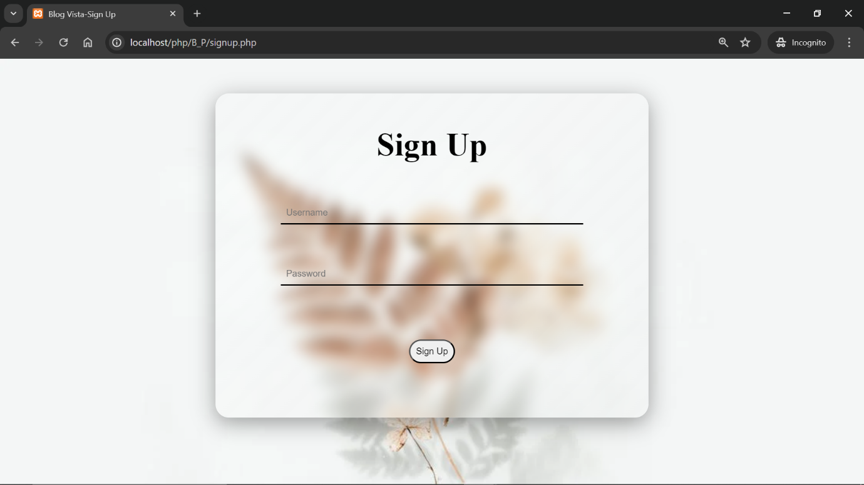

**Sign In**

**Add Post**

**Edit Post**

**My Posts**

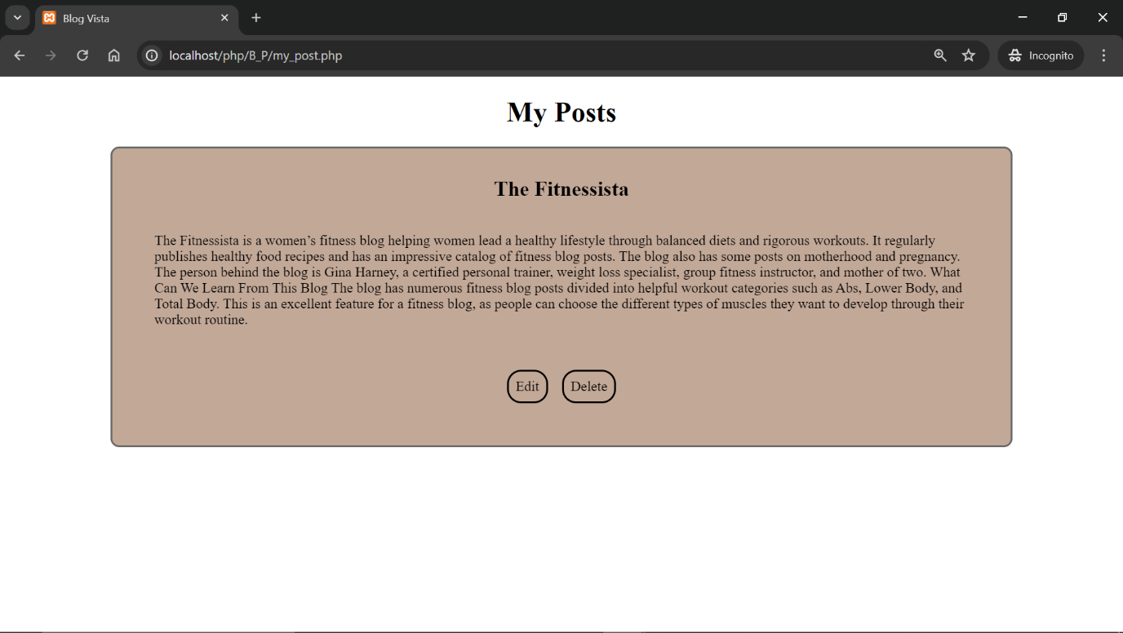

**SOFTWARE MAINTAINANCE**

Software maintenance is widely accepted part of SDLC now a days. It stands for all the modifications and updating done after the delivery of software product. There are number of reasons, Software maintenance in software engineering is the modification of a software product after delivery to correct faults, to improve performance or other attributes.

A common perception of maintenance is that it merely involves fixing However, one study indicated that over 80% of maintenance effort is used for non-corrective actions.

* Why modifications are required, some of them are briefly mentioned below: Market Conditions: Policies, which changes over the time, such as taxation and newly introduced constraints like, how to maintain bookkeeping, may trigger need for modification.
* Client Requirements: Over the time, customer may ask for new features or functions in the software.
* Host Modifications: If any of the hardware and/or platform (such as operating system) of the target host changes, software changes are needed to keep adaptability.
* Organization Changes: - If there is any business level change at client side.
* Software maintenance planning: An integral part of software is maintenance, which requires an accurate maintenance plan to be constructed during the software development. It should specify how users will request modifications or report problems. The budget should include resource and cost estimates.

**TESTING**

**TESTING:**

Testing is the process of executing a program with the intent of finding errors. Although software testing is itself an expensive activity, yet launching of software without may lead to cost potentially much higher than that of testing, especially in systems where human safety is involved. Effective software testing will contribute to the delivery of higher quality software products, more satisfied users, and lower maintenance costs, more accurate and reliable results. Software testing is necessary and important activity of software development process.

**ACCEPTANCE TEST GENERATION:**

The objective of this step is to produce a set of test data that may be used to test the system. Whenever a new system is developed it need to be tested to confirm its validity and to determine whether it meets the user requirements. The system was also tested with some sample records. The records were entered into the system and various reports were generated to check the system. System testing is a critical phase of implementation.

**UNIT TESTING:**

Unit testing focuses on the modules independently locate the errors. This enables the tester to detect errors in coding. It is the process of taking a module and running it in isolation from rest of the software product by using prepared test cases and comparing the actual result with the result redirected with the specifications and design of the module. One purpose of testing is to find and remove as many errors in the software as practical. There are number of reasons in support of unit testing:

* The size of module single module is small that we can locate an error easily.
* The module is small enough that we can attempt to test it in some demonstrably exhaustive fashion.
* Confusing interactions of multiple errors in widely different parts of software are eliminated.
* There is problem associated with testing a module in isolation. How do we run a module without anything to call it, to be called by it, possibly to output intermediate values obtained during execution? One approach is to construct an appropriate driver routine to call it, and simply stubs to be called by it, and to insert output statements in it. Stubs serve to replace modules that are subordinate to the module to be tested. A stub or dummy subprogram uses the subordinate module’s interface, may do minimal data manipulation, prints verification of entry, and returns.

**INTEGRATION TESTING:**

This is a systematic technique for constructing the program structure while at the same time to uncover the errors associated with the interface. The objective is to take unit tested module and build a program structure that has been detected by designing. The main purpose of integration testing is to determine that the interfaces between modules are correct or not. One specific target of integration testing is the interface: whether parameter matches on both sides as to type, permissible ranges, meaning & utilization.

There are 3 types of integration testing:

* Top-Down Approach – Top-Down integration proceeds down the invocation hierarchy, adding one module at a time until an entire tree level is generated.
* Bottom-Up Approach – The Bottom-up strategy works similarly from the bottom to up.
* Sandwich Strategy – A sandwich strategy runs from top and bottom simultaneously.

**STRUCTURAL TESTING:**

Structural Testing considers the internal mechanism of a system or component. Fatigue Testing is carried out with the objective of determining the relationship between the stress range and the number of times it can be applied before causing failure. So, when your product’s structural durability needs to be predicted, verified and validated, turn to DTB's Structural Testing and Fatigue Testing experts. We provide you with the necessary structural testing and fatigue testing equipment and personnel to test the design and manufacturing integrity of your product. Call upon our vast experience in commercial and military applications.

Software Structural Testing:

It is a 2-day course designed to provide an excellent knowledge base and practical skills for anyone interested in improving Software Structural Testing techniques and practices in their organization. This course starts with an overview of software testing basics, including discussions of the importance of software testing, the different levels of testing and basic testing principles. Basic testing terminology is defined. Techniques for ensure test coverage of requirements, different types of testing documentation and various test activities are discussed. Course attendees will learn how to utilize various techniques for performing systematic structural testing, including decision/condition coverage, loop testing and basis path testing. Strategies for performing software and system integration testing are also covered.

**FUNCTIONAL TESTING:**

It is very useful and convenient in support of functional testing. Although JMeter is known more as a performance testing tool, functional testing elements can be integrated within the Test Plan, which was originally designed to support load testing. Many other load-testing tools provide little or none of this feature, restricting themselves to performance-testing purposes. Besides integrating functional testing elements along with load-testing elements in the Test Plan, you can also create a Test Plan that runs these exclusively. In other words, aside from creating a Load Test Plan, it also allows you to create a Functional Test Plan. This flexibility is certainly resource-efficient for the testing project. This will give a walkthrough on how to create a Test Plan as we incorporate and/or configure its elements to support functional testing. This created a Test Plan for a specific target web server. We will begin the chapter with a quick overview to prepare you with a few expectations.

**TEST CASES**

**Information passed** – If a page passes some parameter to another page then it should be checked that the page get the correct information, whatever is passed by the previous page.

**Output should be correct** – Every functionality of the system should be checked properly whether it gives the right result or not generally test is performed with known results. If the output of the system is matched with that result the system is working fine.

**IMPLEMENTATION**

Implementation is the stage in the project where the theoretical design is turned into the working system and is giving confidence to the new system for the users i.e. will work efficiently and effectively. It involves careful planning, investigation of the current system and its constraints on implementation, design of method to achieve the changeover, an evaluation, of change over methods. Apart from planning major task of preparing the implementation is education of users. The more complex system is implemented, the more involved will be the system analysis and design effort required just for implementation. An implementation coordinating committee based on policies of individual organization has been appointed. The implementation process begins with preparing a plan for the implementation for the system. According to this plan, the activities are to be carried out; discussions may regarding the equipment have to be acquired to implement the new system. Implementation is the final and important phase. The most critical stage is in achieving a successful new system and in giving the users confidence that the new system will work and be effective. The system can be implemented only after thorough testing is done and if it found to working according to the specification. This method also offers the greatest security since the old system can take over if the errors are found or inability to handle certain types of transaction while using the new system. At the beginning of the development phase a preliminary implementation plan is created to schedule and manage the many different activities that must be integrated into plan. The implementation plan is updated throughout the Development phase, culminating in a changeover plan for the operation phase. The major elements of implementation plan are test plan, training plan, equipment installation plan, and a conversion plan.

**There are three types of implementation:**

* Implementation of a computer system to replace a manual system.
* Implementation of a new computer system to replace an existing system.
* Implementation of a modified application to replace an existing one, using the same computer.

Successful implementation may not guarantee improvement in the organization using the new system, but improper installation will prevent it. It has been observed that even the best system cannot show good result if the analysts managing the implementation do not attend to every important detail. This is an area where the systems analysts need to work with utmost care.

**Conversion Methods:**

A conversion is the process of changing from the old system to the new one. It must be properly planned and executed. Four methods are common in use. They are Parallel Systems, Direct Conversion, Pilot System and Phase In method.

**Parallel systems:**

The most secure method of converting from an old to new system is to run both systems in parallel. This method is safest one because it ensures that in case of any problem in using new system, the organization can still fall back to the old system without the loss of time and money. The disadvantages of parallel systems approach are: It doubles operating costs. The new system may not get fair trial.

Phase-IN method

This method is used when it is not possible to install a new system throughout an organization all at once. The conversion of files, training of personnel or arrival of equipment may force the staging of the implementation over a period, ranging from weeks to months.

**Post Implementation Review:**

After the system is implemented and conversion is complete, a review should be conducted to determine whether the system is meeting expectations and where improvements are needed. A post implementation review measures the systems performance against predefined requirement. It determines how well the system continues to meet the performance specifications.

**DISCUSSION AND CONCLUSION**

In conclusion, the "Blog Vista" project presents a promising solution to the challenges of information overload, superficial engagement, and lack of authentic connection in the digital landscape. Through a thorough feasibility study encompassing technical, economic, and operational aspects, we have determined that the project is well-positioned for success.

From a technical standpoint, the necessary hardware, software, and development expertise are readily available, ensuring the feasibility of building and maintaining the platform. Economically, viable revenue models and potential return on investment opportunities have been identified, indicating the project's financial viability and sustainability.

Operationally, "Blog Vista" is designed to meet user needs, foster community engagement, and scale with user growth. By prioritizing user acceptance, scalability, and ongoing maintenance and support, the platform is poised to provide a seamless and rewarding experience for users.

In addressing the problem of information overload and fostering meaningful connections through authentic expression and dialogue, "Blog Vista" aims to empower individuals to connect, learn, and grow in the digital age. By creating a space where diverse perspectives are celebrated, voices are heard, and connections are made, "Blog Vista" aspires to be more than just a website; it aims to be a catalyst for positive change in the online community.

As we move forward with the implementation and launch of "Blog Vista," we remain committed to our vision of creating a vibrant, inclusive, and empowering platform for users to share their stories, explore new ideas, and connect with others on a deeper level. Together, let's embark on this journey to shape the future of online discourse and community building with "Blog Vista."

**BIBLOGRAPHY**

* Google search engine
* PHP- MySQL
* www.w3schools.org
* PHP version 8
* www.tutorialspoint.com